

**Financial “deglobalization”?: capital flows, banks, and the Beatles**

Speech given by

Kristin Forbes, Member of the Monetary Policy Committee, Bank of England

At Queen Mary University, London Tuesday 18 November 2014

I would like to thank Ida Hjortsoe, Tsveti Nenova and Dennis Reinhardt for excellent assistance in preparing these remarks and the underlying research. Further thanks to Glenn Hoggarth and

Tomasz Wieladek for helpful input, and to Rob Elder, Don Kohn, Benedict Roth, and Martin Weale for comments. The views expressed are my own and do not necessarily reflect those of the Bank of England or other members of the Monetary Policy Committee. They also do not represent views of the Financial Policy Committee or Prudential Regulation Authority – neither of which am I a member.

In the 1960s, the United Kingdom was at risk of running out of dollars and being unable to maintain its commitment to keep the exchange rate fixed at $2.80/pound. Despite having exchange controls in place that limited the ability of companies and individuals to engage in certain international financial transactions, the country still faced a steady outflow of sterling – partly due to its large trade deficit. The saviour in this case was not the new hero of that decade – James Bond. Or maybe I should say Austin Powers to this crowd given your young average age. Instead, the saviour was the Beatles (with whom this crowd is hopefully familiar despite your age).

How could men with unkept hair, bell-bottom trousers, and the tendency to create unruly crowds and traffic jams contribute to saving the United Kingdom? By touring abroad. Their ticket sales, appearance fees, music royalties, merchandise licensing, and performance rights earned them large sums of foreign currency, which they then brought home and converted to sterling.1 From 1964 to 1966 the Beatles toured in the United States and other foreign countries, earning world-record dollar concert receipts. Media reported that they could earn as much as $650/second in today’s dollars. These foreign receipts are booked as “service exports” in international accounting terms and helped reduce the UK’s current account deficit.

But even the Beatles could not help prop up the UK forever. The band’s last commercial concert was in the summer of 1966. The UK faced renewed pressure to earn enough foreign exchange to support its fixed exchange rate and finance its current account deficit. Just one year later, it was forced to abandon its peg, sterling was devalued by 14% against the dollar, and the UK signed an emergency IMF loan package.

Today, it is hard to imagine any large, advanced economy being reliant to the same extent on the

foreign-currency earnings of a single band. Instead, exchange controls have been gradually lifted since the era of the Beatles (albeit at different rates in different countries). This has allowed individuals, companies, and banks to substantially increase their international borrowing and investment, so that countries have become much more financially integrated over time. Figure 1a shows one measure of cross-border financial integration – the sum of capital flowing into and out of a country by foreigners and domestic residents each year (scaled as a share of global GDP) for a group of advanced economies with data back to 1970.2 These capital flows were miniscule in the days of the Beatles when compared to the recent period – which is why the actions of one band (albeit a very impressive band) could have a meaningful effect.

1 The information on the role played by the Beatles in supporting the pound is from International Monetary Fund (2014a).

2 This is gross capital flows into each country, expressed as a percent of the total GDP of all countries in the sample. “Gross” capital inflows is asset purchases by foreigners - capital flows from foreigners into the country - net of their sales (outflows). Gross capital

outflows is defined symmetrically for domestics.

**Figure 1a: Gross capital inflows and outflows for selected advanced economies(a) 1970-2007**

% of GDP

50

Gross capital inflows and outflows

45

40

35

30

25

20

15

10

5

0

1970 1980 1990 2000

1. Sample of countries: Australia, Austria, France, Israel, Italy, Netherlands, Sw eden, United Kingdom, United States.

Source: IMF International Financial Statistics, OECD

**Figure 1b: Gross capital inflows and outflows for selected advanced economies(a) 1970-2013**

% of GDP

50

Gross capital inflows and outflows

40

30

20

10

0

-10

1970 1980 1990 2000 2010

(a) Sample of countries: Australia, Austria, France, Israel, Italy, Netherlands, Sw eden, United Kingdom, United States.

Source: IMF International Financial Statistics, OECD

There has been extensive discussion of the risks and benefits of financial globalization, much of which has rested on the assumption that global financial integration is an unstoppable trend. But was that just “Yesterday” (to cite the Beatles)? Figure 1b extends Figure 1a with the most recent data available.

International capital flows fell sharply during the crisis and show no signs of recovering to the levels seen pre-crisis. Cross-border financial flows for these countries (scaled by the size of their economies) are now as “globalized” as they were in the year 1983. Is *financial deglobalization* a more accurate description of today than *financial globalization*?

The remainder of my comments will explore four questions. First, is there broader evidence of financial deglobalization – especially in the United Kingdom? I will show that the answer is yes. Second, what is driving this trend? I will show that a massive contraction in global bank flows is the culprit, and this is particularly important for the UK. Third, what is driving these changes in international capital flows – especially bank flows? I will show that international bank flows no longer appear to respond to similar drivers as before the crisis (namely global risk). Finally, what are the implications of this deglobalization in banking flows for the United Kingdom and monetary policy? I will discuss a number of considerations – some of which could be substantive – such as affecting how vulnerable the UK is to different types of shocks and making monetary policy more effective. Although it will take more than a “Hard Days Night” and “Eight Days a Week” – to fully understand these trends and their implications.

Financial globalization? Or financial deglobalization?

The previous figures that I showed you with evidence of financial deglobalization focused only on the

cross-border flows of capital for a small set of countries for which data was available back to 1970. Do these findings hold more broadly? The short answer is yes. Figure 2 shows international capital flows since 1980

for all countries in the world (for which data is available), and for the UK. Global financial flows show the same pattern of increasing over time (particularly in the 2000s), falling sharply during the crisis, and not rebounding to anything close to pre-crisis levels. International capital inflows are now only 1.6% of global GDP, ten times less than the peak of 16% in 2007.

**Figure 2: Global gross capital inflows and outflows for world**

**Figure 3: Sum of foreign assets and liabilities of advanced economies and UK, scaled by GDP (1980- present)**

% of UK

GDP 50

World gross capital inflows + outflows (RHS)

UK gross capital inflows

+ outflows (LHS)

40

30

20

10

0

-10

-20

-30

-40

-50

% of world

GDP

20

15

10

5

0

-5

-10

-15

-20

% of UK GDP 1600

1400

UK foreign assets + liabilities (LHS)

AEs' foreign assets + liabilities (RHS)

1200

1000

800

600

400

200

0

% of AEs' GDP

600

500

400

300

200

100

0

1980 1985 1990 1995 2000 2005 2010

Source: IMF International Financial Statistics, ONS

1970 1980 1990 2000 2010

Sample includes 21 advanced economies.

Sources: Lane and Milesi-Ferretti (2007), IMF IFS, IMF WEO, ONS

Figure 3 shows another measure capturing the extent to which financial globalization has changed – including patterns for the United Kingdom. Instead of focusing on financial flows in any year, it graphs the stock of cross-border financial exposure (foreign assets plus liabilities as a share of GDP) that has accumulated over time. According to this measure, financial globalization increased rapidly, especially in the 2000’s, and then this seemingly inexorable trend toward greater financial globalization faltered. According to this measure, UK cross-border financial exposure has not only stopped increasing, but fallen by 23% (or almost 440ppts of GDP) since its peak, so that it is currently at its level in late 2007.

To further highlight the dramatic shift that has occurred, Figure 4 replicates the previous Figure 3 since 2000 and includes trend lines based on the average pace of financial integration from 2000 through 2007. The gaps today between the trend lines and the current values of the international exposures indicate how much globalization has been “lost” relative to if pre-crisis trends had continued. For example, if cross-border financial positions had continued to grow at pre-crisis trends, they would be equivalent to about 670% of GDP in advanced economies today, instead of their current 420% of GDP. In the UK, international financial exposure would be over 15 times GDP – about 25% higher than today. Granted, this comparison is not entirely fair as the pre-crisis trend was built on a number of unsustainable factors – but this is the same

comparison often used to measure the “lost” output or productivity growth since the crisis.3 The “loss” in financial globalization has been even greater.

**Figure 4: Sum of foreign assets and liabilities of**

**advanced economies and UK, scaled by GDP (2000- 2013)**

**Figure 5: Home bias in advanced economies**

1

Cross-sectional correlation

between domestic savings and

investment as % of GDP

% of UK GDP 1600

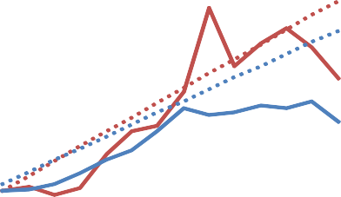

1400

1200

1000

800

600

400

% of AEs' GDP

800

700

600

500

400

300

200

100

1980 1990 2000 2010

0.8

0.6

0.4

0.2

0

-0.2

200

0

2000 2004 2008 2012

UK foreign assets + liabilities (LHS) UK 2000-07 trend (LHS)

AEs' foreign assets + liabilities (RHS) AEs 2000-07 trend (RHS)

Note: Home bias is greater if the correlation betw een domestic savings and investment is higher. The correlations from 2014 onw ards are based on latest WEO forecasts for savings and investment. Sample of advanced countries includes: Australia, Austria, Belgium, Canada, Cyprus, Denmark, Finland, France, Germany, Greece, Hong Kong, Iceland, Ireland, Israel, Italy, Japan, South Korea, Luxembourg, Netherlands, New Zealand, Norw ay, Portugal, Singapore, Spain, Sw eden, Taiw an, United

Sample includes 21 advanced economies.

Sources: Lane and Milesi-Ferretti (2007), IMF IFS, IMF WEO, ONS

Kingdom, United States.

Source: IMF World Economic Outlook October 2014

A final approach for assessing the extent of any financial deglobalization is to look at “home bias”. One measure of home bias is the degree to which investment moves with the level of savings in the country. In countries that are not financially globalized, investment must be funded through savings by domestic individuals, companies, or the government. In countries that are more financially globalized, investment can also be funded through borrowing from abroad, so that domestic investment and domestic savings do not move as closely. The classic way to measure home bias is to estimate the correlation of domestic investment and savings in an economy. Appendix A shows these estimates for the 1980s, 1990s, pre-crisis 2000s, and post-crisis period, and Figure 5 shows the cross-sectional correlations by year using this methodology. Home bias started to fall in the 1990s and reached very low levels in the mid-2000’s, at which time the world was highly financially globalized. Home bias then increased rapidly during the crisis and is currently at levels similar to in 1994. According to this measure, financial globalization has sharply reversed and shows little signs of returning even to levels of the late 1990s.4

There are a number of reasons why these various measures of global financial integration could have been interrupted during the crisis, and may not return to their previous peaks. But it is remarkable that they have

3 For example, there has been much debate on the UK productivity gap, which is often cited as a loss of 16% relative to where it would have been today if productivity growth had continued at its pre-crisis trend. See Barnett et al. (2014).

4 One caveat to using this correlation coefficient as a direct home bias measure is that it might reflect the incidence of common shocks which affect domestic savings and investment of all countries to different degrees. See Giannone and Lenza (2009) for further detail.

remained at such depressed levels for such an extended period and despite the broader recovery in the global economy.

What has caused this financial deglobalization? Decomposing deglobalization: banking is the culprit

Before taking a closer look at what is driving this recent deglobalization in financial flows, I would like to make one important point on exactly what flows we should be examining. Traditionally, most international economic analysis has focused on net capital flows to a country – basically the flip side of a current account balance. Countries that run current account deficits – such as the UK today (and in the era of the Beatles) – need to attract net capital inflows to pay for the country’s excess of imports over exports.5 Countries have been able to run larger current account imbalances over time, financed by larger net capital flows that are part of increased financial globalization. These flows were largely driven by foreign investors. But, as capital flows have increased, the most impressive changes in capital flows have not been in these net capital flows, but in the gross flows underlying them. More specifically, net capital flows is the “net” of capital flowing into a country from foreigners and capital flowing out of the country by domestics. Figure 6 shows these different components for Chile (on the left) and the United Kingdom (on the right): net flows, gross foreign inflows, and gross domestic outflows.6 It shows that the magnitude of the gross flows driven by foreigners and domestics has increased by much more than the net flows.

**Figure 6: Net capital inflows, gross inflows and gross outflows for Chile (left-hand panel) and the UK (right-hand panel)**

ion 15

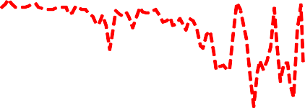

Net Inflows

Gross Inflows (Foreigners) Gross Outflows (Domestics)

US $ bill

10

5

0

-5

-10

-15

Net Inflows

Gross Inflows (Foreigners) Gross Outflows (Domestics)

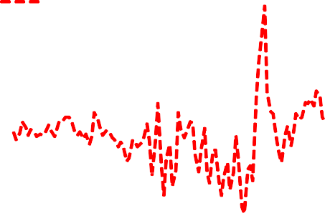

£ billion

100

80

60

40

20

0

-20

-40

-60

-80

-100

1990 1995 2000 2005 2010

Source: IMF International Financial Statistics, ONS

1987 1992 1997 2002 2007 2012

5 Other factors, such as transfer payments and earnings on past investments, also affect the current account deficit.

6 Following standard balance-of-payments accounting, domestic flows are reported using a negative sign, so that −$10 billion signifies a capital outflow by domestic residents of $10 billion.

So why does this matter? This matters for two reasons. First, focusing on net capital flows – as has traditionally been done – ignores the huge increase in the size of cross-border financial flows and the corresponding extent of financial globalization that has occurred. The scale of these gross capital flows relative to net capital flows is particularly striking for the UK, in which changes in net capital flows barely register on the graph when measured on the same axis as the gross flows. During many periods, and especially in the UK, movements in gross inflows and outflows broadly mirror each other, partly reflecting the role of international banks as intermediaries for various types of financial flows.7

Second, breaking flows into those driven by foreigners and domestics can be important to understand exactly what is driving overall capital flow movements. It is no longer appropriate to assume that most of the volatility is driven by just foreigners; even for an emerging market such as Chile. For example, consider the period around 2008 for Chile. If you follow the standard approach of just looking at net capital flows (the black line), the graph could be interpreted as suggesting that at the peak of the global financial crisis – as financial markets around the world were freezing up – foreigners decided to send money to Chile. Although I have the greatest respect for Chile’s economic policies, I find it hard to believe that citizens of the US and UK suddenly decided that they should move their savings to Chile in 2008. Instead, to understand what actually happened, it is illuminating to decompose these net capital flows into those driven by foreign and domestic investors. Foreign capital flows into Chile basically dried up in 2008 – as happened in many countries in the world. Chileans, however, including those managing Chile’s sizeable pension funds, invested less abroad at the same time. This “retrenchment” of capital brought home more than balanced the decline in flows from abroad. Focusing just on net capital flows would have missed these important dynamics.

**Figure 7: Global gross capital inflows by asset Figure 8: Global gross capital outflows by asset**

ld Gross Banking outflows (inc. other)

Gross Banking inflows (inc. other) Gross Portfolio inflows

Gross FDI inflows

Total gross inflows

% of wor GDP

10 Gross Portfolio outflows Gross FDI outflows

% of world GDP 4

8 Total gross outflows 2

6 0

4 -2

2 -4

0 -6

-2 -8

-4

1980 1985 1990 1995 2000 2005 2010

1980 1985 1990 1995 2000 2005 2010

-10

Note: Flows related to bank bond issuance and bank buying of marketable debt are included in portfolio inflows and outflows rather than in banking flows.

Source: IMF International Financial Statistics

7 For example, international banks can intermediate between foreign investors or depositors and savers. They can also engage in financial transactions by international companies which are likely to invest abroad using funds raised from foreign investors.

In addition to breaking capital flows into where they are coming from (foreign vs. domestic), it is also possible to disaggregate them by the type of capital. I will focus on three categories: banking flows, portfolio flows (which include equity and debt), and foreign direct investment (or FDI, which is when the investor has a larger equity stake in an enterprise). Figures 7 and 8 show total flows by foreigners and domestics, respectively, for the entire world, broken into these three categories.8 Both figures show that all types of capital flows declined during the crisis – but especially banking. International banking flows not only fell to zero, but reversed, indicating that banks not only stopped lending money abroad, but also liquidated foreign exposures to bring money home. Portfolio flows and FDI have both since stabilized at positive (albeit somewhat lower) levels since the crisis, while banking flows have continued to contract recently. In other words, banks around the world appear to currently be reducing their foreign exposures and bringing money home – driving the recent trend in financial deglobalization.

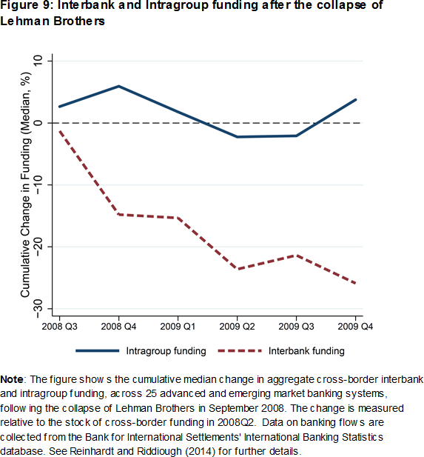To better understand this decline in international banking flows, it is possible to further decompose these flows into those which are “interbank” and “intragroup”. Interbank transactions are

arms-length transactions which take place between unrelated banks resident in different countries.

Intragroup transactions take place between resident banks and their foreign affiliates (either subsidiaries or branches) and occur through internal capital markets.9 Figure 9 decomposes international bank flows for all BIS reporters into these two components and shows that the decline in international bank flows since the crisis is primarily driven by a decline in interbank funding. In just the UK, intergroup as well as interbank flows both

contracted sharply from 2009, although with a larger fall in interbank liabilities. Additional analysis suggests that intragroup flows between parent banks and their foreign subsidiaries have been more stable than between parents and their foreign branches.10

The result of this contraction in international bank lending – especially between banks resident in different countries– has been a major contraction in the global banking network. This contraction is captured

8 I will refer to the red as banking flows, although technically it is the IMF’s “other flows” category. This is primarily banking, but also includes additional categories, such as trade credit and SDR allocations, amongst others.

9 See Reinhardt and Riddiough (2014) for additional information on these different types of transactions and their characteristics.

10 See Hoggarth, Hooley, and Korniyenko (2013) for additional information on the different trends in intragroup lending between foreign parent banks with their subsidiaries and their branches in the UK. The main differences between these entities are that a foreign branch is: legally inseparable from its parent, not separately capitalised, and supervised and insured by the home authority. It is easier to move

funds between parent banks and their branches as compared to their subsidiaries.

graphically in Figure 10.11 Each dot represents a country, and the lines represent bank flows between the countries, with the size of the lines and dots representing the magnitude of the corresponding financial centre or bilateral banking flows. Both figures show the extensive network of banking flows that links economies around the world. The change in the size of the dots and density of the lines from 2008 Q3 to 2013 Q3 captures how this international banking network has contracted. The contraction in banking flows related to the UK (denoted by GB at the bottom of the sphere) is particularly striking.

Figure 11 further highlights the magnitude of this contraction in the UK by showing the cumulative decline in international banking from 2008 Q4 through 2013 Q4 (broken into assets/loans and liabilities/borrowing) for a set of countries, with the left panel expressed as a share of world GDP and the right as a share of

own-country GDP. The UK clearly stands out. The contraction in UK international lending and borrowing is larger – on an absolute basis – than for any other country for which data is available. In other words, the decline in bank flows into and out of the UK has contributed more to the global decline in banking flows than any other country. When this contraction in bank flows is measured relative to country size, several smaller countries have had relatively larger contractions, but the UK is still among the five countries most affected. There was a roughly similar decline in UK resident bank lending to and borrowing from abroad, and this banking deglobalization even affected some of the most sophisticated global banking institutions. For example, HSBC withdrew from consumer banking in more than 20 countries (leaving it with operations in about 40 markets today) and Citi has cut its retail banking presence almost in half to 24 countries.12 It is also worth noting that although this bank deglobalization was substantial in many advanced economies, other countries further away from the epicentre of the financial crisis not only avoided this deleveraging, but increased their international banking flows (most notably in Japan).

11 Thanks to Hoggarth et al. (2010) for inspiring the use of this pictoral framework.

12 *Financial Times,* “Big Banks Losing Interest in Global Ambitions,” by Martin Arnold and Camilla Hall. Oct. 20, 2014.

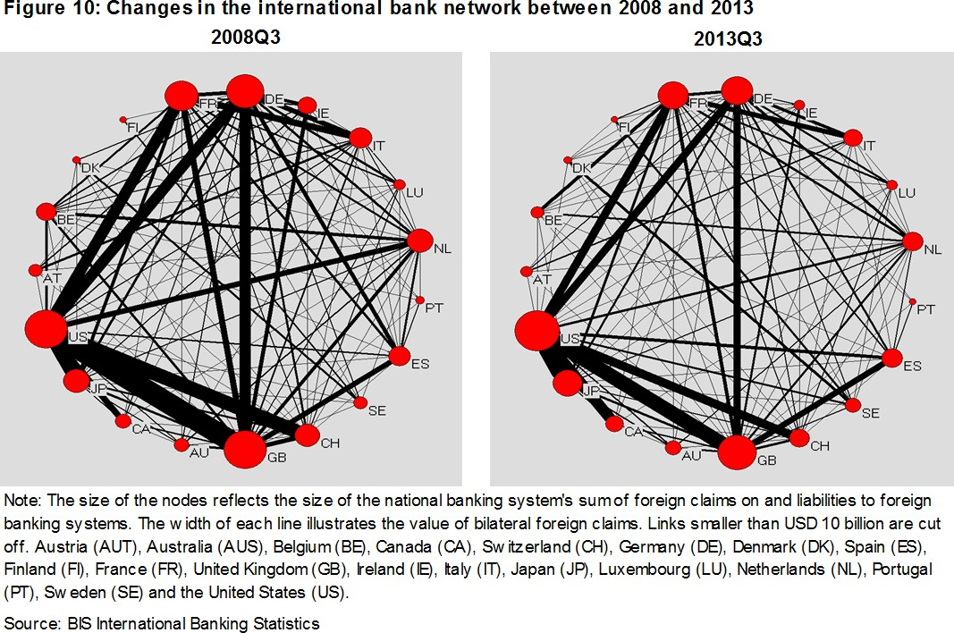

**Figure 11: Cross-Border Banking after the Collapse of Lehman Brothers, 2008 Q4 vs. 2013Q4**

Cumulative Change in Cross-Border Banking Assets and Liabilities 2008Q4 to 2013Q4 **(% of world GDP**)

%

-1

0

1

%

-50

-100

0

50

Cumulative Change in Cross-Border Banking Assets and Liabilities 2008Q4 to 2013Q4 **(% of own GDP**)

# 

Assets Liabilities

Assets Liabilities

Note: The figure on the left shows the cumulative change in cross‐border bank assets and liabilities vis‐à‐vis foreign bank and non‐bank sectors following the collapse of Lehman Brothers in 2008Q3. The change is measured as the sum of exchange‐rate‐adjusted changes in assets or liabilities between 2008Q4 and 2013Q4 relative to world GDP at 2008Q3. In the figure on the right, the change is measured relative to own country GDP at 2008Q3.

-2

Japan Canada Australia Sweden Taiwan Korea India Brazil Mexico Turkey Italy Austria Spain

Luxembourg

Netherlands

France United States

Ireland Switzerland Germany

United Kingdom

-150

Taiwan Sweden Japan Australia Canada Korea India Brazil Mexico Turkey

United States

Italy Spain France Germany Austria Netherlands

United Kingdom Switzerland

Ireland

Luxembourg

-169

-215

-412

-321

The contraction in UK international bank flows is therefore a critically important part of the global contraction in bank flows and the corresponding financial deglobalization. This should not, however, be surprising given the important role that the UK plays in the global banking system. Figure 12 shows the volume of

international bank loans (between banks) by country at the end of 2013 – after the sharp contraction – with darker colours signifying greater global exposure. The UK stands out as providing more international loans (bank-to-bank assets) than any other country in the world. At the end of 2013, UK resident banks provided over $2.6 trillion in international loans, followed by US banks with about $2.1 trillion. About 15% of international interbank activity is booked in the UK, down only slightly from about 17% in 2007. Any reduction in global bank loans from the United Kingdom (or United States) will have global repercussions.13

**Figure 12: Map of cross-border bank assets in absolute levels**

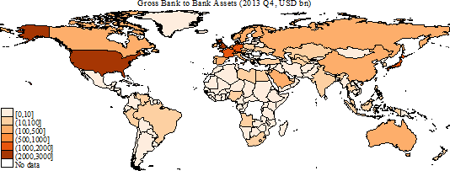

Source: BIS International Banking Statistics and IMF WEO

**Figure 13: Map of cross-border bank liabilities in % of own GDP**

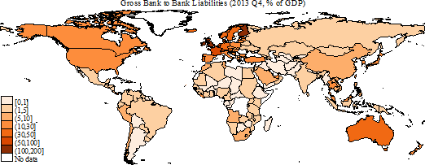

Source: BIS International Banking Statistics and IMF WEO

But not only do changes in UK international bank flows have repercussions for the world, any changes in global bank flows can have meaningful consequences for the UK economy. Figure 13 shows international bank borrowing by country, scaled by each country’s GDP. The United Kingdom continues to stand out (now along with Finland) as having the highest exposure to international banks. UK interbank lending is

13 Liabilities for China and other non-BIS reporters are proxied using assets of BIS reporters. Van Rijckeghem and Weder di Mauro (2014) show that countries with the largest foreign international banking exposure had the largest decline in exposure since the crisis.

equivalent to 104% of GDP – even after the massive contraction documented above.14 Foreign banks also play a major role in the UK banking system; for example, there are currently 145 branches of international banks operating in the UK, accounting for 31% of the total assets (loans) in the UK banking system and equivalent to about 160% of annual UK GDP.15 When the UK subsidiaries of foreign banks are included in these calculations, their role is even greater.

Any changes in UK international banking flows and exposures clearly have global implications. Changes in global banking flows and exposures clearly have important implications for the UK. Therefore understanding what has driven recent changes is important for the UK as well as the global economy.

What is driving banking deglobalization?

What has caused this striking reduction in international bank flows? And why have other types of capital flows rebounded (as shown in Figures 7 and 8) – but not bank flows? Many logical explanations for why international banking contracted during the crisis should be less binding today – such as uncertainty about counterparty risk, limited dollar funding, maturity mismatch between assets and liabilities, and impaired balance sheets that forced banks to reduce lending to rebuild capital.16

To better assess exactly what is driving these trends, it is useful to take a step back and consider what drives capital flows more broadly. Are bank flows traditionally more volatile? If so, what drives this? Are bank flows influenced by different factors than other types of capital flows? And have any of these relationships changed since the crisis?

Figure 14 shows the volatility in total capital inflows (from foreigners) and outflows (by domestics), as well as for its three main components: banking flows, portfolio flows, and FDI. The left panel reports volatilities for all advanced economies and the right focuses on just the United Kingdom. Volatility is measured by the coefficient of variation, which captures the volatility of each unit of the relevant flow relative to GDP.17 Banking flows are substantially more volatile than portfolio flows and FDI. Banking flows from foreigners also appear to be slightly less volatile than banking flows driven by domestics. These patterns apply to the set of advanced economies as a whole as well as for the UK. Total capital inflows and outflows are somewhat more volatile for the UK than the average for advanced economies, despite each type of flow being somewhat less volatile individually. This reflects the larger share of banking flows in UK international flows than the average, combined with the higher volatility in international banking flows.

14 Figures 12 and 13 include only international bank-to-bank lending and borrowing. Due to data limitations, they do not include bank lending and borrowing to non-bank institutions. Figures constructed based on the IMF’s IFS data on “other” borrowing and lending, which includes all international bank lending (plus some other cross-border flows) shows very similar patterns to those discussed above. 15 Source: Bank of England (2014).

16 See Hill and Hoggarth (2013) and Hoggarth et al. (2010) for more details on these explanations.

17 This scales the standard deviation by the absolute value of the mean of each flow category in order to adjust for the size of each flow. It uses detrended flows as a share of GDP based on 10-year rolling windows, as suggested by Bluedorn et al. (2013).

What drives this volatility in the different types of capital flows – and especially banking flows? There is a long history of academic research trying to answer this question. This literature often classifies the forces driving capital flows into “push” factors and “pull” factors. Push factors are external to the country and generally outside of its control (such as changes in global risk aversion, interest rates in major economies, global growth, global liquidity, oil prices, and contagion effects). Pull factors are domestic macroeconomic and institutional factors that can be more directly influenced by the country (such as domestic growth, inflation, debt sustainability, corporate governance, and capital controls). Recent academic work has highlighted the “global financial cycle” that drives capital flows to advanced as well as emerging markets and emphasizes the critical role of changes in global risk aversion, US interest rates, and global banking conditions (especially leverage).18

**Figure 14: Average coefficients of variance for gross capital flows by asset class for advanced economies (left chart) and for UK (right chart) over 1980-2013**

Coefficient of variance

5

4

3

2

1

0

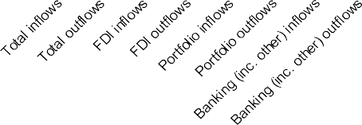

Source: IMF International Financial Statistics

Coefficient of variance

5

4

3

2

1

0

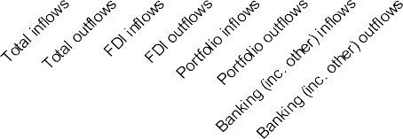

Can these research insights, including recent work on the “global financial cycle”, explain recent patterns in capital flows and especially in banking? To test this, we extend the framework in Reinhardt and Riddiough (2014) and Bruno and Shin (2013) and estimate how different variables affect banking flows, portfolio flows, and FDI by foreigners and domestics.19 Appendix Table 1 shows the key regression results. For the period from 2000 through 2009, the results agree with previous research. Lower levels of global risk and decreases in global risk are correlated with significantly greater international portfolio flows and especially banking flows. (FDI is less sensitive to global risk – but strongly correlated with host country GDP growth). This important role of risk is supported by a number of studies; when risk aversion and/or economic uncertainty is

18 For further discussion and examples of this literature, see Forbes and Warnock (2012), Rey (2013), and Bruno and Shin (2013).

19 We regress capital flows as a percent of GDP using quarterly data. The historic window is 2000q1−2009q4 and the post-crisis window is 2010q1−2013q4. The sample is the 20 advanced economies that are BIS reporters. We focus on results measuring risk using the VIX

* the implied volatility of S&P 500 equity index options. Key results are unchanged if we instead measure risk using the volatility risk premia (or VRP), which is intended to isolate changes in risk aversion (and exclude economic uncertainty). Key results are also unchanged if we follow Bruno and Shin (2013) and control for broker dealer leverage, instead of risk. The table reports results for gross capital inflows from foreigners (liabilities), but results are the same for gross capital outflows by domestics (assets). For the analysis of banking flows, the key results are unchanged if we use IFS data on other capital flows – which is largely banking flows – instead of the BIS data on flows in bank assets or liabilities to all sectors. All variables are winsorized at the 5% level and offshore financial centers (Luxembourg and Cyprus) are excluded.

low or falling, it is easier for banks to borrow internationally (such as from money market funds in financial centres) and the value of their equity increases. This allows them to increase leverage and increase lending abroad.

When this analysis is repeated for the post-crisis period, however, there are noteworthy changes in the results – but only for bank flows. Banking flows are no longer significantly affected by the level of or changes in global risk. In contrast, portfolio flows continue to be negatively and significantly correlated with changes in global risk, and FDI continues to show no relationship – both as found before the crisis. Global bank flows

* unlike the other types of flows – no longer appear to be driven by the same forces that affected them before the crisis. These results are confirmed in the Appendix Table 1b which repeats the same analysis for percent changes in bank assets and liabilities (ie, for changes in international banking positions scaled by initial banking stocks instead of flows scaled by GDP as before).

Why do international banking flows and stocks no longer seem as sensitive to changes in global risk? Why have these relationships changed for bank flows since the crisis – but not for portfolio flows and FDI? Are there other factors to consider? The list of possible explanations is long, and evaluating each of them is beyond the reach of these comments. But let me suggest some factors that may be contributing to the recent deglobalization in banking, but have less effect on other types of capital flows.

1. *Higher costs for banks to go abroad:* Domestic banks tend to be better informed about local conditions than international banks (a type of asymmetric information), especially during crises and periods of economic change. This makes it more difficult for foreign banks to compete during these periods. The costs of negotiating and monitoring abroad may also have increased, especially as many economies have adopted different responses to the crisis. The large penalties applied for misconduct and insufficient oversight may have aggravated all of these risks, making bank managers more reticent to have large overseas operations or lend directly cross-border.
2. *Reduced access to wholesale funding*: Before the crisis, many banks financed lending partly through deposits and partly through wholesale funding, i.e. loans from international investors such as

money-market mutual funds. This source of funding was particularly important for foreign banks, but dried up during the crisis. Hoggarth, Hooley, and Korniyenko (2013) show that this form of “fickle” funding was particularly important for foreign branches in the UK (relative to UK-owned banks and foreign subsidiaries in the UK), and that these branches have contracted lending more than domestic banks and foreign subsidiaries.

1. *Weakness in individual bank balance sheets*: Many banks’ balance sheets were negatively affected by the crisis, due to factors such as investment losses and higher default rates. Vulnerable banks had to rebuild their balance sheets by bringing home money from abroad, reducing lending (both domestically and internationally), and/or raising capital through other sources. According to some measures, UK

banks looked weaker on average in 2007 than in many other developed countries, contributing to their greater need to strengthen balance sheets, deleverage, and reduce lending more in subsequent years.20

1. *Weakness in the demand for loans:* Even if banks were healthy and willing to lend internationally, companies and individuals may have been more reluctant to borrow after the crisis, including from banks based abroad, due to the increase in economic uncertainty. In some cases, companies and individuals may also have been less willing to increase borrowing as they needed to pay down debt to strengthen their own financial positions.
2. *Repercussions of crisis-resolution packages:* During the crisis, a number of banks received large financial support packages from their governments. It has been suggested that in some of these cases, as part of this financial support, banks may have been encouraged to hold domestic assets (such as domestic government bonds), increase domestic lending (possibly at the expense of foreign lending), and reduce foreign exposures.21
3. *Regulatory changes:* Banking regulation has changed dramatically since the crisis – both at the global level as well as through individual country reforms. Changes were clearly needed to address many of the vulnerabilities in the global banking system that became apparent during the recent crisis. These regulatory changes should increase the resilience of banks in the future, as well as make economies less vulnerable to problems in the banking system. They could also have important effects on

cross-country bank flows. For example, increased restrictions, regulations, or capital requirements on foreign currency exposure or any type of international exposure could make international transactions more costly. Increased requirements for foreign banks– such as no longer allowing foreign branches and instead requiring foreign banks to establish any presence through subsidiaries (which require more capital and reporting requirements than branches) – could reduce risks to domestic economies but also make international banking more costly.

20 Van Rijckeghem and di Mauro (2014) and Cerutti and Claessens (2014) both provide empirical evidence that weaker banks deleveraged more during the crisis.

21 Cerutti and Claessens (2014) note that banks were often asked to focus on domestic lending when receiving government support and find that banks reduced direct cross-border and affiliates lending equally in countries where governments intervened during the crisis, possibly reflecting the larger induced home bias. Van Rijckeghem and Weder di Mauro (2014) conjecture that financial protectionism,

taking different forms, might have induced home bias as countries with more damaging banking crises reduced their international lending most. Using a panel dataset of UK-resident banks, Rose and Wieladek (2014) find that, after nationalization, foreign banks reduced British lending as a share of their total lending and increased interest rates on new loans to UK residents. However, they find no significant effect of the nationalisation of British-owned banks on their lending activity or interest rates.

**Figure 15: Average minimum capital requirement ratio for UK banks**

# % of RWA

15

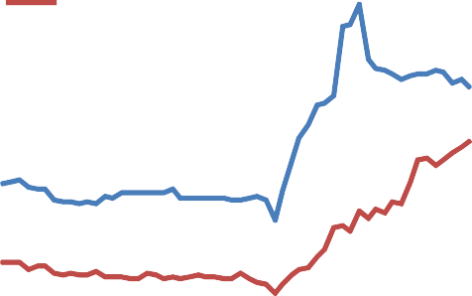

Unweighted

Weighted by bank RWA

14

13

12

11

10

9

8

2000 2003 2006 2009 2012

Note: RWA stands for risk-w eighted assets. Source: Bank of England

Even increases in minimum capital requirements that did not differentiate between international and domestic lending could contribute to reduced leverage in banks and the decline in global (as well as domestic) lending. Any such reduction in international lending could be proportionally larger than for domestic lending if the risk-weightings on international lending were greater. Figure 15 shows the average minimum capital requirements for UK banks since 2000, and the sharp tightening that has occurred since the crisis. This tightening is typical in many economies as they seek to strengthen their banking systems and prepare for the implementation of the global Basel III requirements. Research shows that increases in these types of capital requirements lead to a decline in bank lending, at least in the short run, and some (but not all) work suggests that the resulting decline in international lending is greater than for domestic lending.22 Increased regulations that reduce bank

flows today but ensure a more robust financial system, however, could better support higher levels of

financial globalization in the future.23

Some – or all – of these factors have undoubtedly contributed to the recent deglobalization in banking. There may also be other influences that are not on the list. But one key question remains. What are the implications of this deglobalization in banking for the United Kingdom and monetary policy?

Implications for the United Kingdom and monetary policy

There has been an extensive debate on the benefits and costs of financial globalization. During the 1990’s and 2000’s, much of this discussion focused on its potential benefits – especially for these advanced economies with stronger institutions and financial systems. For example, financial globalization could make it easier for firms and countries to access financing for productive investment. It would allow capital to flow

22 For example, see Aiyar et al. (2014a,b) and Cerutti, Claessens, and Ratnovski (2014). Aiyar, Calomiris, and Wieladek (2014b) examine data from 1998-2007 and find that bank lending growth falls by about 5.7% within a year following a 100 basis point rise in bank-specific capital requirements; while Bridges et al. (2014) find a decline in lending of about 2.7%. In a separate contribution, Aiyar, Calomiris, Hooley, Korniyenko and Wieladek (2014a) find that cross-border bank lending declines by about 5.4% following a 100 bps rise in capital requirements over the same time period. Preliminary work by Wiedelak (2014) finds a significant reduction in bank lending after increased capital requirements in the UK, but no significant difference in the effects on international relative to domestic lending.

23 Consistent with this view, Governor Mark Carney noted in a speech yesterday that “where banking systems have raised capital and restored trust in their creditworthiness, access to credit has returned”. See speech, “The Future of Financial Reform”, given on

17 November 2014.

freely to its most productive uses and improve risk diversification, therefore generating higher returns. It could improve “market discipline”, as investors rewarded countries for sound policies and pressured those without.

More recent discussion, however, has shifted to more vocal concerns about “Globalization and its Discontents” (to cite a popular book by Joseph Stiglitz). For example, financial globalization can make countries more vulnerable to contagion and events that occur outside their borders. The “surges” of financial inflows can feed inefficient credit booms, asset price bubbles, and overvalued exchanges rates, while the “stops” of financial flows can feed currency collapses and banking crises. Most recently, increased attention has been paid to whether financial globalization can foster inequality or complicate the ability of a country to run an independent monetary policy to support its domestic economy.24

Given the scope and complexity of this debate on the costs and benefits of financial globalization, I will not make any attempt to address all of these issues. Instead, in the remainder of my comments, I will focus on one specific angle of this debate: what are the implications for the United Kingdom and the Monetary Policy Committee of a less globalized banking system? The implications are wide-ranging, and I will focus on nine

* 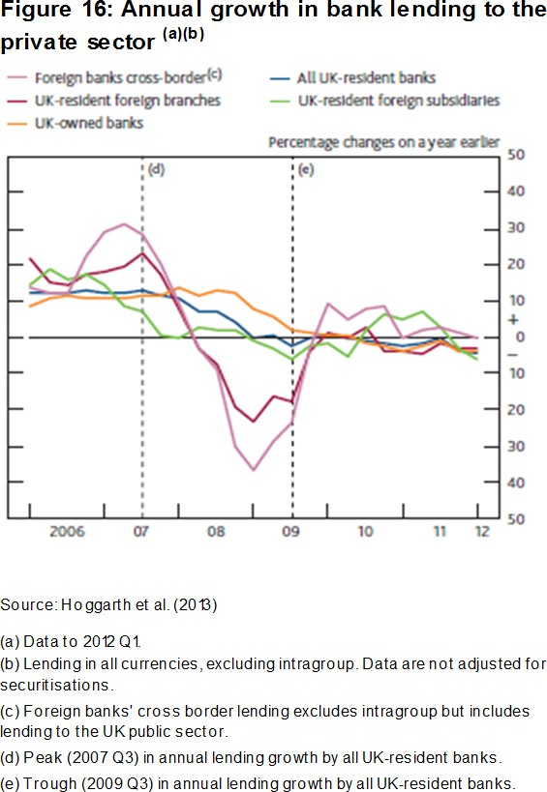although there are certainly more.

First, if certain sectors of the economy (such as businesses or SMEs) were more reliant on foreign banks for funding, these groups may have more difficulty obtaining access to credit in the future.25 Figure 16 shows that bank lending to the UK private sector by foreign banks made cross border and from their local branches fell sharply during the financial crisis. Hoggarth, et al. (2013) show that foreign branches can be important sources of credit for UK companies. Small- and medium-sized enterprises are also more reliant on banks for funding than larger companies, so they could be most vulnerable to a decline in aggregate bank lending. It is difficult to know if they would have greater difficulty accessing credit in the future, however, if UK banks simultaneously reduce lending abroad, thereby increasing their pool of funds available for domestic

24 For example, see Rey (2013), which argues that monetary policy is less effective in more financially integrated economies.

25 Ongena, Peydro, and van Horen (2013) show that when foreign banks reduced their local lending during the crisis, this affected local firms and especially small ones and those with limited tangible assets. This study draws on a diverse set of countries, however, many of

which have less developed domestic financial systems, so it is unclear if this result applies to the UK.

lending and counteracting the reduction in lending by foreign banks within the UK. Closely related, an inefficient allocation of credit has been proposed as one possible factor behind low productivity growth in the UK since the crisis,26 and reduced banking flows may have played some role. Recent reforms to strengthen the overall banking system, plus specific programs designed to improve the access to credit for groups that could be most vulnerable (such as the Funding for Lending Scheme) could help ameliorate any of these risks.

Second, a reduction in cross-border flows and transactions should lead to simpler and more transparent global banking institutions. Figure 6 documented that the rapid growth in international banking corresponded to a largely simultaneous increase in flows into and out of banking systems. Many of these flows did not represent bank’s traditional role of lending to non-financial corporations financed by deposits. Instead, a portion of this increase in international bank activity corresponded largely to banks acting as intermediaries in a range of complex transactions that involved taking on liquidity, duration, and currency risk, as well as counterparty risk. This led to an extremely complex, leveraged, and untransparent financial system, making it difficult to assess the underlying risks and understand how problems in one institution could affect others and the broader economy. The recent deleveraging and simplification of international banking should make it easier to understand inherent risks and exposures in the future, supporting efforts to avoid “too big to fail” situations in major financial institutions in the future.27

Third, and closely related, reduced activity by global banks, and especially this simplification in their international transactions, could reduce liquidity in different markets and therefore increase volatilities and the risk of sharp and disorderly price swings. International banks traditionally played an important role as counterparties and market-makers for a range of transactions. As they play a less active role matching buyers and sellers today, some risks from market illiquidity may have increased (despite the large amounts of liquidity provided by central banks as part of their asset-purchase programs).28 This decreased role of banks in stabilizing markets may have played a role in the market turbulence in October, and is frequently raised in discussions of the stability of funding for emerging markets. On the other hand, much of banks’ cross-border intermediation of funds before the crisis may have been related to high levels of leverage, and reducing this leverage may reduce volatility and the risk of sharp price swings.

Fourth, a less globalized banking system could increase the cyclicality of domestic credit to domestic shocks. As UK banks lend less abroad, and foreign banks lend less in the UK, the total UK credit supply will be more tightly linked to the domestic supply of credit and business cycle. This stronger home bias will increase the sensitivity of credit and lending to domestic shocks and changes in domestic banks. In other words, in a less globalized banking system, international banks will be less likely to access external funding sources to

26 See Barnett et al. (2014) for a discussion of the UK productivity puzzle.

27 For further discussion, see Governor Carney’s speech, “The Future of Financial Reform”, given on 17 November 2014.

28 For further discussion, see Gillian Tett, *Financial Times,* “Markets are Parched for Liquidity Despite a Flood of Cash”, Oct 17, 2014.

smooth any fluctuations in UK credit.29 Since banks are simultaneously reducing their leverage and strengthening balance sheets in other ways, however, this increased resilience of banks overall could mitigate their vulnerability to domestic cyclical effects – especially if combined with measures such as counter-cyclical capital buffers.

Fifth, and closely related, although a deglobalized banking system may increase the correlation between domestic lending and domestic shocks, it could simultaneously reduce the correlation with foreign shocks.30 There is a long literature showing how negative events in one country can cause banks in that country to withdraw lending to other countries, possibly causing a contraction in credit in the country that was not directly affected by the initial event.31 Research shows that more leveraged banking systems are particularly vulnerable to “contagion” and any negative shocks that originate abroad.32 If two countries had highly synchronized business cycles or similar vulnerabilities to common shocks, then this benefit of reducing the amplification of foreign shocks could be even greater. The reduction in cross-border exposure, especially when combined with the lower levels of leverage and stronger balance sheets, should substantially increase the resilience of UK banks to foreign shocks.

Sixth, as international banks in advanced economies such as the UK reduce their foreign exposure, this could facilitate the expansion of international banking in less represented countries. Before the crisis, advanced economies were responsible for the bulk of international bank flows – far more than would be expected based purely on the size of their economies. Figure 11 shows that even though most advanced economies have seen a significant reduction in their international banking assets and liabilities, banks in other countries have been partially filling this gap – especially in Japan, but also in several emerging markets.33 In some cases, emerging-market banks have even been buying assets from advanced-economy banks as they reduce their foreign exposures. Figure 17 shows that this increase in cross-border banking exposure for emerging markets and other advanced economies that did not have banking crises has been fairly small to date, in comparison to the overall contraction in the global banking network. (Data for China is not available, however, and anecdotal reports indicate that Chinese banking institutions have been increasing their international exposure over this period). If these trends continue, however, this could be the start of a larger shift in which the UK plays a less important role, and emerging markets and other advanced economies a more important role, in the international banking network.

29 See Reinhardt and Riddiough (2014) and Cetorelli and Goldberg (2012b) for a discussion of how these internal fund transfers in international bank groups functioned during the crisis. See Hoggarth et al. (2013) for evidence that foreign banks tend to be less pro-cyclical in their lending.

30 Cesa-Bianchi, Imbs, Saleheen (2014) show that increased banking integration may lead to higher business cycle synchronization.

31 Peek and Rosengreen (1997) showed the earliest evidence of these effects, using the experience of Japanese banks. Cetorelli and Goldberg (2012a) and Giannetti and Laeven (2012) provide more recent evidence on the strength of these effects.

32 For evidence, see Forbes (2013).

33 For additional evidence, see see Claessens and Van Horen (2014).

**Figure 17: Cross-Border Banking after the Collapse of Lehman Brothers, 2008 Q4 vs. 2013Q4**

**Figure 18: UK banking and shadow bank(a) assets as % of GDP**

Bank assets

0

2

% of UK GDP

1200

Shadow bank assets

1000

%

-4 -2

800

600

-6

400

-8

_

200

Liabilities Liabilities Liabilities

AEs with systemic banking crisis - Assets AEs without systemic banking crisis - Assets EMEs - Assets

Note: The figure shows the cumulative change in cross-border bank assets and liabilities of BIS reporting countries vis-à-vis foreign bank and non-bank sectors following the collapse of Lehman Brothers in 2008Q3. The change is measured as the sum of exchange-rate-adjusted changes in assets or liabilities between 2008Q4 and 2013Q4 relative to world GDP at 2008Q3. We classify countries as having suffered a systemic banking crisis or not, using the database compiled by Laeven and Valencia (2013).

0

2002 2004 2006 2008 2010 2012

Source: Bank of England, ONS.

(a) This chart show s a broad measure of shadow banking

w hich includes all assets of other financial intermediaries and is likely to significantly overestimate the true size of the UK shadow banking sector.

Seventh, another response to any funding shortfall created by reduced banking flows could be to encourage the development of alternative financing sources – such as through what has been called the “shadow banking system” (i.e. asset-backed securities, money-market funds, hedge funds, amongst others). The IMF has recently discussed how increased banking regulations which reduce global bank flows could support the growth of shadow banking.34 The FSB recently reported that shadow banking assets rose to a record

$75 trillion last year, equivalent to about half of the global banking system. There is also some evidence, such as shown in Figure 18, that lending by shadow banks in the UK has increased moderately as lending by traditional banks has declined. Shadow banking can play a beneficial role as a complement to traditional banking by improving access to credit, market liquidity, and risk sharing. But shadow banking can also involve risks – especially if the corresponding institutions are not regulated and present systemic vulnerabilities. Central banks and international institutions are aware of these potential benefits and risks.35

Eighth, a reduction in international bank flows could make it more difficult, and possibly even more expensive, for the UK to fund its current account deficit. Figure 19 shows that the UK current account deficit (the black line) has recently been increasing. The latest data indicate that it was 5.2% of GDP in 2014 Q2 (on an annualized basis) – only slightly lower than the record of 5.6% it reached in 2013 Q3. It is also unlikely that this deficit will fall in the near future given the strength of demand in the UK relative to that in its major trading partners. This deficit must be funded through some type of capital flows from abroad. The coloured bars in Figure 19 show how the current account deficit has been funded in the past – broken into banking (and other) flows, portfolio flows, and FDI – with a negative value indicating a net positive contribution to this funding gap. Net international bank flows have been an important source of funding since

34 International Monetary Fund (2014b).

35 For example, the BoE and ECB have recently launched an initiative to make securitisation markets in the EU safer and more integrated. See Bank of England and European Central Bank (2014) for further detail.

the crisis (mainly resulting from UK banks reducing foreign exposures and retrenching), although they fell sharply in the last year for which data was available (2013).36 If this trend continues, the UK will become increasingly dependent on other forms of financing. The UK could become more vulnerable to changes in the behaviour of international portfolio investors, possibly making it more vulnerable to negative shifts in sentiment that could cause increases in borrowing rates or a sterling depreciation. As shown in Figure 14, however, portfolio flows have been more stable than bank flows in general – so the form of these flows and underlying investors would be important in determining vulnerability. A foreign exchange crisis as occurred in the era of the Beatles is unlikely, however, due to changes such as the move to a flexible exchange rate.

**Figure 19: UK current account balance for 1993- 2013 and which flows fund it**

DP

Bank and other flows Portfolio flows

FDI flows

Current account

% of G

20

15

10

5

0

-5

-10

-15

-20

-25

1994 1997 2000 2003 2006 2009 2012

Note: The sign of net financial account flow s is reversed to match the current account balance, so that a positive FDI flow should be interpreted as a net FDI outflow , or UK investors acquiring more assets abroad than foreign investors acquired in the UK.

Last, but certainly not least, this deglobalization in banking could influence the functioning of monetary policy

– both for conventional changes in interest rates and non-conventional policy. There is extensive evidence that global banks respond to changes in the cost of borrowing, liquidity, and other funding conditions by transferring funds across borders through their internal capital markets. For example, if Bank Rate and the corresponding borrowing costs and deposit rates in the UK increased relative to other countries, global banks would raise more of their funding in other markets (such as by shifting customer deposits from countries which pay lower interest rates to their UK branches or subsidiaries). This could allow them to increase loans in the UK without paying the higher cost of capital related to the increase in Bank Rate.

These internal transfers within banking groups can partially insulate global banks from changes in domestic interest rates.

These internal transfers can also counteract some of the intended impact of monetary policy on the economy. For example, if one of the goals of raising Bank Rate is to increase the cost of borrowing and reduce the supply of credit in the UK, international banks which access cheaper funding through their operations in other countries may instead increase their supply of credit in the UK to compensate for any reductions in lending by domestic banks. Analysis suggests that, in the past in a cross-section of countries, these countervailing flows through international banks can be so large that they almost entirely counteract

36 Net banking flows are calculated as the net change in funding after summing the effects of the reduction in foreign bank flows to the UK with the reduction in UK bank funding sent abroad.

the lending contraction in domestic banks after monetary policy tightening.37 Granted, these effects would be smaller in countries with large financial systems such as the UK, and monetary policy works through other channels then lending. But it does suggest that as global banking networks contract, there may be less room for cross-border banking flows to counteract the lending channel for monetary policy. As a result, traditional monetary policy could become more effective in a world of less globalized banking networks.

Internal fund transfers within globalized banking networks can also impact non-conventional monetary policy. For example, when the ECB held LTRO auctions in December 2011 and February 2012, which provided the opportunity for banks in the euro area to access cheap funding for low-grade collateral, some UK banks shifted collateral from their UK operations to their subsidiaries and branches in a euro-area country. This allowed them to borrow at the lower rates, after which they quickly shifted the cheaper funds back to the UK. Euro area banks with UK operations were also able to take advantage of the cheaper funding, which they then could shift to the UK and lend outside the euro area. As banking systems reduce their foreign exposures, these opportunities for the internal transfer of funds and “leakages” of unconventional monetary policy could be reduced.

Conclusions

The global economy has become substantially more integrated than in the days of the Beatles. We do not live in “A Yellow Submarine” and economies are constantly rocked by waves originating elsewhere. As pointed out in *The Economist* this week, many measures of global interconnectedness continue to increase and are at higher levels than before the crisis – such as for information and people (including tourists, students, and migrants).38 For other measures, however, the seemingly inexorable trend of increased globalization may be abating – and even reversing. International capital flows are sharply lower than before the crisis, and international financial exposures are somewhat lower. Home bias is greater. This recent financial deglobalization is driven by a massive contraction in international banking flows – in which the UK plays a critical role. Not only have UK resident banks withdrawn more cross-border lending than any other banking system, but other countries’ banks have reduced their cross-border lending exposure to the UK on a scale that is large even when measured relative to the scope of the UK economy.

This deglobalization in banking flows is particularly striking when compared to trends in other types of capital flows. Foreign direct investment and portfolio flows (equity and debt) have rebounded more quickly (albeit not fully to pre-crisis levels) and appear to be driven by the same factors as before the crisis. In contrast, banking flows are still contracting, and appear to no longer be driven primarily by changes in global risk and economic uncertainty as occurred before the crisis. There are many possible explanations for these changes.

37 For evidence of these effects and estimates of their magnitudes, see Cetorelli and Goldberg (2014) and Reinhardt and Riddiough (2014).

38 For further details, see “Signs of Life”, *Economist*, Nov 15, 2014,

This deglobalization of banking will have widespread repercussions for the United Kingdom, including for the Monetary Policy Committee. A reduced international banking network could affect: access to credit for certain sectors; the safety and transparency of international banks; liquidity and volatility in some markets; the role for other countries and shadow banking in providing financial services; and how the UK current account deficit is financed. Most relevant to monetary policy, this reduction in cross-border banking exposures could reduce vulnerability to external conditions but increase vulnerability to domestic economic conditions. Global banks will be somewhat less likely to transfer funds across borders to bypass changes in funding costs and liquidity resulting from changes in monetary policy. As a result, the lending channel of monetary policy is likely to be more effective in the future.

Of course, this discussion of banking deglobalization and its implications should not be interpreted as suggesting that this era of broader financial globalization and large global banking institutions is at an end. Major financial institutions will continue to be active across borders and the global banking network will remain an important source of capital flows and financing, especially as a better capitalized and more resilient institutions emerge from the crisis. The era when the foreign currency earnings from one band’s international tour were required to support a major economy is over. But it may be time to shift from focusing on the implications of increasing levels of financial globalization, to a serious discussion of the implications of banking deglobalization.

**Appendices**

**Appendix A: Home bias for different periods**

**Appendix charts:**

**Average 1980s**

50



y = 0.70x + 8.65 R² = 0.63

UK

**Average 1990s**

50



y = 0.52x + 11.56 R² = 0.58

UK

40 40

in % of GDP

in % of GDP

30 30

20 20

Investment

Investment

10 10

0

0 10 20 30 40 50

Savings in % of GDP

0

0 10 20 30 40 50

Savings in % of GDP

**Average 2000-2007**

50



y = 0.08x + 21.73 R² = 0.02

UK

**Average 2010-2013**

50

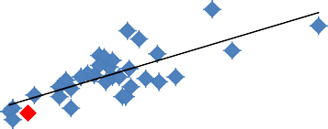

y = 0.38x + 12.31 R² = 0.57

UK

40 40

Investment in % of GDP

Investment in % of GDP

30 30

20 20

10 10

0

0 10 20 30 40 50

Savings in % of GDP

0

0 10 20 30 40 50

Savings in % of GDP

Note: Home bias is greater if there is a steeper slope of the line (corresponding to a larger estimated regression coefficient). Source: Based on data from IMF World Economic Outlook October 2014

## Appendix B: Regression results

**Table 1a: Regressions with capital flows to GDP as dependent variables**

|  |  |  |  |  |  |  |  |  |  |  |  |  |  |
| --- | --- | --- | --- | --- | --- | --- | --- | --- | --- | --- | --- | --- | --- |
| (I) | | |  | (2) | (3) |  | | (4) | (5) |  | | (6) | |
|  | | | FDI |  |  | Port闪 io | |  |  | Banking | |  | |
|  | | Before 2009.Q4 | Afte r 2叩9:Q4 | | Before 2009Q4 | | Afte r 2009:Q4 | | Before 2009Q•I | | Afte r 2009:Q4 | | |
| VIX | | 0. I. |  | | -1.: | |  | | -2. | | l.98 | | |
|  | | (0.13) | (0.5G) | | (0. ，11) | |  | | (0.77 ) | | (1.34) | | |
| VIX Grow t J, | | 0.li | 0.19 | | -2 3.1＊噙水 | |  | | -3 15• .. | | 2 ss• | | |
| 0.23 0.46 0.81 1.00 1.62 | | | | | | | | | | | | | |
| ER Dep 设 iat10 11 | | 1.22* | 0.08 | | -1.33 | -2.19 | | | -10.05*** | 2.93 | | | |
|  | | (0.67) | (1.13) | | (!AO) | (2.24) | | | (2.90) | (<1.73) | | | |
| A IR S prcad | | 0 30• | 0.20 | | -0 33• | 0.4 L | | | 0.55 | 1.30 | | | |
|  | | (0.17) | (0.30) | | (0.19) | (0.52) | | | (Q.4,1) | (1.45) | | | |
| lI1”al.iOIl | | 0.08 | -0.14 | | -0,.01 | o.02 | | | 0.00 | 0.55 | | | |
| ( .0 1.6.)• | | | ( 0 . 13) | | (0.16) | (0.18) | | | (0.21) | (0.51) | | | |
| CDP Growth 0.05 | | | -0.05 | | -0.02 | 0.08 | | | 0 12*** | -003 | | | |
|  |  | (0.01) | (0.03 ) | | (0. 04) | (0.06) | | | (0.0•1) | (0.12 ) | | |  |
|  | t;. Public Debt | -0.06 | -0.01 | | -0.35 | 0.10 | | | -0.55' | 0.08 | | |  |
|  |  | (0.09) | (0.05) | | (0.2S) | (0.14) | | | (0.28) | (0.27) | | |  |
|  | Constn 叫 | 0 97 ** | -0. 86 | | G0 6** * | 48 8* | | | 9 01 *** | -089 | | |  |
|  |  | (0.43) | (1.63) | | (1.20) | (1.85) | | | {2.33) | {4.04) | | |  |
|  | 0 1 卖 rvat io n. | 771 | 3 19 | | 77 1 | 319 | | | 764 | 320 | | |  |
|  | R-squared | 0.31 | 0.37 | | 0.63 | 0.48 | | | 0.25 | 0.15 | | |  |
|  | CouIIMi(名. | 20 | 20 | | 20 | 20 | | | 20 | 20 | | |  |

．

Notc ,TIe Iabi c p,t 的 心 如 四 i，几（心 i {J{"' " 11.eter vnl，心 f，加1 fm ed-cff“ S 加” cI 啼 心 如 IS 卯 （，如 lple o1 2O wlu”“ ccd " 'I)no my B/S m1)()心 rs T 加 （如 心 叫 叩 呻 如 s the flow of FD! l，心血 心，＇1 祁, re nt of CDP i11 呻 m11s ( 1丿' md (2) 四 rtf oho 侐奾 tg flows m 沁 戏, 1 t o/ C DP m columns (3,) md (4丿und t1比 邸 tima lcd动 (,IIgc mtC (， 如，, 应 如 ngc i1， 如 11!.·. 如 屈 it 心 ，“ 1 吓 叩 of GDP ,in columns (5) and ((}) . VI X is /he ,II,m 如 ·ly nve roge of the lag VIX in 如 ．while t, VIX 切

tI比 (luurt叫 u ch”“qe m the u“ emge 如 el of 加 吩 VIX m 如 T he VIX - I(，如 from tl,e Cl,ioo_qo B如 tl Opt“' ，s E 动 ”“ ye (C BOE ) - is « ＂，如纽飞of ＠ 叩 nic 门 sk 凶 ／c ula 比 d 加 scd on the implied volatili ty of short-dated options on the S&P equity ind 立 ． Standa rd er 而 S, clust 叩 d at count 叨 如 el. are report ed in bmc 朊 / . 拿＊＊，s si ,l＇｝,fi” 以（＇！ 加 1% 1切 el, " at tl,e 5% level a,,d • at the t O% level. D血 on FD I a, 讨 炒 计foh o flOWS” m f rw n t如 IMF.s IFS 如（，如e. D仙．，如 k·,nkm9如ws ur它叫 她 l ed f,-om the Bunk fo r lrrt 叮 1心 如 (d Set Ue m,臼 ts· /111勺 l ut1°”“ l B”“ 如 19 Stu 沁, t CS (lutubuse. Th e s”“' plC 沁 ,iad is 如 m 2000QJ to 20J 9 Q./.

## Table 1b: Regressions with percent changes in the stock of foreign exposures as dependent variables

(1) (2) (3) (4)

Bank i 叨 Lia biliti es B a nking Assets

Before 2009:Q4 Arte 『 如 ·Q4 Before 20 叩 Q4 Aft er 2009·Q4 VIX -2.82... 163 重 3 32... I 愧

(0 切） ( I 5D) (0.63 ) { I 3 1 )

VL'LGl'owlh -2.58* 3.2G -3,25*.. 2.98

I 23 205 1.03 l 95

E ll Depreciat ion -14. 74*＊零 , . 83 -8.03* 匕1,14 (3 65) (715) (4.37 ) ( G95)

t!. IR Spread l. 01 1.10 0.25 O, 17

。

(0.62) (1.76) (0.78 )

Infla tion 0.40 0.38 0.13

(0汹）

.33

(0 •11)

0( , 61) (OA I ) (0 55)

GDP Growth o.1s• .. 0 16 0. 10 0 22

- 0( 0. .450*0)* (0 1 3 ) (0.08) (O19}

|  |  |  |  |  |  |  |
| --- | --- | --- | --- | --- | --- | --- |
|  | /:. Public Debt | (0 20) | 0.18  0( •17 ) | . 0.54· ·  (0心I) | 0.16  ( 0 况） |  |
| Constant | L0.57** * | 6,O2 | 12,G4* ＊＊ | 3.99 |  |
|  | (2.00) | (4.96) | (1.99) | (3 82) |  |
| O 炽汜r邓 t ions | 763 | 320 | 763 | 320 |  |
| R-squ八red | 0 16 | 0 13 | 0.12 | 0 14 |  |
|  | co un tr ies | 20 | 20 | 20 | 20 |  |

Notc. The t”ble p飞sents tlie estimat叫 沁 mmeter val呤 l mrf，应或－e JJ 必 ts 1沁" el l匆戊SS·也ll-S On a 占”“ l,)/e oJ 20 ad如 心 I econ如 y /JJS 飞 卯 lt C、l s. T he dependent

四 l气mble ” ih e q，而如 ly 釭 chmIge ，血 “， lj 1凶 ted 1如 如 1叩 心 1ge m ，，/，社 如 奾 缸 s m 心 ／UIIl心 ( 1) and (2) and 如 人心的 “ ' II O /m叩 (SJ a,ul (,1). v rx is 1加

q' 叩 呻 归 lf ge o/ , tIC 彻 VIX md 扛 ， wl1,le A VI x, s the q 叩 如 ／y c/m?,g e m t he av..,uge Ic0c/ oj 如 1的 VIX in 缸 ． T 加 VIX - t. 。 如 J 如 II tI,c Chi 位 go BOO 讨

卯 t1OllS 阮 ／umg e (C l)0 £) • is a m叩 叩 of 切 11o micr is " 如 Int.ed 如 ai on II,C U/lp/?“ ” o i心 li t.y of sf叩 －小心 I o pt．砌 lS Qn, II e S8 P ” l urty u忐 ．S血（如 I

,石 o为，cl心如 说 (lt o u ，切 如 el, “' 它，如 r l ed in bn u:k心 ． 亭亨本” “ g mj奴 ml at /he 1 % level, 亨本 a t tile, % level a11d 拿 al tile 10 % le邪 I. Data or, 如 血 g fl o四 叩

叫 位 叫 from 从e /Ja11k Jo,· ln tem atio 11al Setti e m口 Us I nt印 ra tio rud Ba r从让g Stat 过七s data 加se . Tire sampl e 沁，切d is from 2000Q1 to 2019Q4

25

**References**

Aiyar, Shekhar, Charles Calomiris, John Hooley, Yevgeniya Korniyenko and Tomasz Wieldak. (2014a). “The International Transmission of Bank Capital Requirements: Evidence from the United Kingdom.” Bank of England Working Paper No. 497.

Aiyar, Shekhar, Charles Calomiris and Tomasz Wieldak. (2014b). “Identifying channels of credit substitution when bank capital requirements are varied.” Bank of England Working Paper No. 497.

Bank of England and European Central Bank. (2014). “The case for a better functioning securitisation market in the European Union.” Discussion Paper.

Bank of England. (2014). “Supervising International Banks: the Prudential Regulation Authority’s Approach to Branch Supervision.” Prudential Regulation Authority Consultation Paper CP4/14.

Barnett, Alina, Sandra Batten, Adrian Chiu, Jeremy Franklin and Maria Sebastia-Barriel. (2014). “The UK productivity puzzle.” Bank of England Quarterly Bulletin, vol. 54(2), pages 114-128.

Bluedorn, John, Rupa Duttagupta, Jaime Guajardo, and Petia Topalova. (2013). “Capital Flows are Fickle: Anytime, Anywhere.” IMF Working Paper WP/13/183.

Bridges, Jonathan, David Gregory, Mette Nielsen, Silvia Pezzini, Amar Radia and Marco Spaltro. (2014).”The impact of capital requirements on bank lending.” Bank of England Working Paper No. 486.

Bruno, Valentina and Hyun Song Shin. (2013). “Capital Flows, Cross-Border Banking and Global Liquidity.” NBER Working Paper 19038.

Cerutti, Eugenio and Stijn Claessens. (2014). “The Great Cross-Border Bank Deleveraging: Supply Constraints and Intra-Group Frictions.” IMF Working Paper WP/14/180.

Cerutti, Eugenio, Stijn Claessens and Lev Ratnovski. (2014). “Global Liquidity and Drivers of Cross-Border Bank Flows.” IMF Working Paper WP/14/69.

Cesa-Bianchi, Ambrogio, Jean Imbs and Jumana Saleheen. (2014). “Finance and Synchronization” Mimeo.

Cetorelli, Nicola and Linda Goldberg. (2012a). “Follow the Money: Quantifying Domestic Effects of Foreign Bank Shocks in the Great Recession.” *American Economic Review: Papers and Proceedings,* 102(3):

213-218.

Cetorelli, Nicola., and Linda Goldberg. (2012b).“Liquidity Management of U.S. Global Banks: Internal Capital Markets in the Great Recession," *Journal of International Economics* 88, 299-311.

Cetorelli, Nicola and Linda Goldberg. (2014). “Banking, Globalization and Monetary Transmission.” *Journal of Finance.* Forthcoming.

Claessens, Stijn and Neeltje Van Horen. (2014). “The Impact of the Global Financial Crisis on Banking Globalization.” IMF Working Paper WP/14/197.

Forbes, Kristin. (2013). “The ‘Big C’: Identifying and Mitigating Contagion.” *The Changing Policy Landscape.*

2012 Jackson Hole Symposium hosted by the Federal Reserve Bank of Kansas City, pgs. 23-87.

Forbes, Kristin and Francis Warnock. (2012). “Capital Flow Waves: Surges, Stops, Flight and Retrenchment.” *Journal of International Economics* 88(20): 235-251.

Giannetti, Mariassunta, and Luc Laeven. (2012). “Flight Home, Flight Abroad, and International Credit Cycles.” *American Economic Review: Papers and Proceedings,* 102(3): 219-224.

Giannone, Domenico and Michele Lenza. (2009). “The Feldstein-Horioka Fact.” NBER International Seminar on Macroeconomics, Vol. 6, No.1 (2009), pgs. 103-107.

Hills, Bob and Glenn Hoggarth. (2013). “Cross-Border Bank Credit and Global Financial Stability.”

*Bank of England Quarterly Bulletin 2013Q2.*

Hoggarth, Glenn, John Hooley, and Yevgeniya Korniyenko. (2013). “Which Way do Foreign Branches Sway? Evidence from the Recent UK Domestic Credit Cycle.” Bank of England Financial Stability Paper No. 22.

Hoggarth, Glenn, Lavan Mahadeva, and Jeremy Martin. (2010). “Understanding International Bank Capital Flows During the Recent Financial Crisis.” Bank of England. Financial Stability Paper No. 8

International Monetary Fund (2014a). *Finance and Development.* September. Pgs. 48-49.

International Monetary Fund (2014b). *Global Financial Stability Report.* Washington DC: International Monetary Fund. October.

Laeven, Luc and Fabián Valencia. (2012). “Systemic Banking Crises Database: An Update.” IMF Working Paper WP/12/163.

Philip R. Lane and Gian Maria Milesi-Ferretti. (2007). "The external wealth of nations mark II: Revised and extended estimates of foreign assets and liabilities, 1970–2004". Journal of International Economics 73, November, 223-250.

Ongena, Steven, José-Luis Peydró, and Neeltje van Horen. (2013). “Shocks Abroad, Pain at Home? Bank-Firm Level Evidence on Financial Contagion during the Recent Financial Crisis.” Mimeo.

Peek, Joe and Eric Rosengreen. (1997). “The International Transmission of Financial Shocks: The Case of Japan.” *American Economic Review* 87(4): 495-505.

Rey, Hélène (2013). “Dilemma not Trilemma: the Global Financial Sector and Monetary Policy Independence.” Paper presented at the Federal Reserve Bank of Kansas City’s Symposium in Jackson Hole (August 2013).

Reinhardt, Dennis and Steven Riddiough. (2014). “The Two Faces of Cross-Border Banking Flows: An Investigation into the Links Between Global Risk, Arms-Length Funding and Internal Capital Markets.” Bank of England Working Paper No. 498.

Rose, Andrew and Tomasz Wieladek. (2014). “Financial Protectionism? First Evidence.” The Journal of Finance, Vol. LXIX, No. 5, pgs 2127-2149.

Van Rijckeghem, Caroline and Beatrice Weder di Mauro. (2014). “Deglobalization of Banking: the World is Getting Smaller.” CEPR Working Paper No. 10139.